Word | Sentence/Context | Meaning
Defective | If I have children, there’s a one-in-two chance that I will pass on the defective gene to them.
Flabbergasted | Double stunned. Stung. Flabbergasted. No words formed in my mouth.
Vibe | I was getting a really bad vibe from him.
Syndrome | But I also have this other syndrome thing that I can’t even pronounce.
Sympathetic | “Come on, Jaime!” said Mom angrily. “I honestly thought both my boys were more sympathetic than that.”
Inkling | Although I don’t know the details, I have an inkling about what may have sparked the confrontation with Julian.
Confrontation | Although I don’t know the details, I have an inkling about what may have sparked the confrontation with Julian.
Retrospect | In retrospect, and having now seen the child in question at various school functions and in the class pictures, I think it may have been too much to ask of our children to be able to process all that.
Empathy | I thought it would teach them a thing or two about empathy, and friendship, and loyalty.
Neutral | I guess even though she was neutral, she didn’t want to be seen with me.
Abnormality | she didn’t tell me about august until our third date. i think she used the phrase “a craniofacial abnormality” to describe his face.
Immaculate | i sit down on the rolling chair by her desk. her room is immaculate.
Interjects | the mom interjects as she cleans the floor, to see if i’m okay with his bringing home some homeless guy’s dog.
Adore | it takes the most fragile creations in ways we can’t see. like with parents who adore you blindly and a big sister who feels guilty for being human over you.
Unsuspecting | It was like starting school all over again, having unsuspecting adults pass me on the stairway.
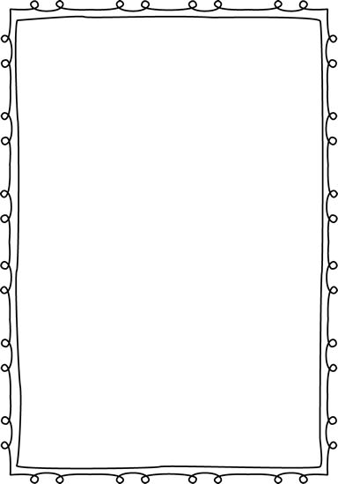
Vocabulary Chart Week 2

