Word | Sentence/Context | Meaning
Taciturn | “But what is with you lately, Via? You’re moody and taciturn and secretive….”
Rickety | The stage was completely empty except for Justin, who was sitting on an old rickety chair tuning his fiddle.
Et cetera | Really? So sorry! That must be tough! Et cetera. Et cetera. I regretted saying this the moment it escaped from my lips, of course: I felt like such a fake.
Flubbed | There was one line she flubbed a bit, but Justin covered for her, and no one in the audience even noticed.
Euphoric | It was that crazy backstage theater mayhem where sweaty actors stand euphoric while people come worship them for a few seconds.
Detached | When I was really little, that was mainly because there were too many medical issues, like my trache tube needing to be cleared every hour, or reinserting my feeding tube if it got detached.
Spritzed | But luckily I had spritzed myself before I left the cabin, and I wasn’t eaten alive like some of the other kids were.
Dome | Out here in the fairgrounds, I could understand why ancient people used to think the world was flat and the sky was a dome that closed in on top of it.
Roaming | Do not go into the cornfields or the woods. Please keep the free roaming to minimum.
Devouring | “Chocolate milk, please?” I started devouring the sandwich.
Seismic | When I went back to school the next day, the first thing I noticed was that there was a big shift in the way things were. A monumental shift. A seismic shift.
Polyphonic | Just follow the day and reach for the sun! (The Polyphonic Spree)
Revelation | I mean, to me this was a major revelation, and he was acting like it was no big deal.
Cusp | Because you’re at the cusp, kids. You’re at the edge between childhood and everything that comes after.
Capacity | Why I love that line, that concept, is that it reminds me that we carry with us, as human beings, not just the capacity to be kind, but the very choice of kindness.
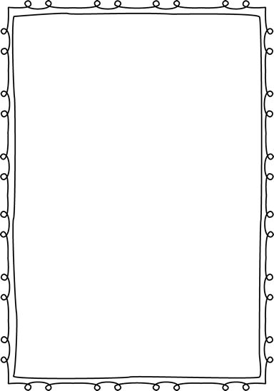
Vocabulary Chart Week 3

